Report for the Degree of Bachelor of Computer Engineering

Internship Report on the Role of
Mobile App Developer at CODE IT



Manish Shrestha
(2022-1-07-0141)

Pokhara Engineering College
Faculty of Science and Technology
Pokhara University, Nepal

Spring, 2026

Report for the Degree of Bachelor of Computer Engineering

Internship Report on the Role of
Mobile App Developer at CODE IT

Supervised by: Asst. Prof. Er. Shiva Kunwar
Internal Supervisor

A report submitted in partial fulfilment of the requirements for the degree of Bachelor of Computer Engineering

Manish Shrestha
(2022-1-07-0141)

Pokhara Engineering College
Faculty of Science and Technology
Pokhara University, Nepal

Spring, 2026

Issued On: August 9, 2026

CERTIFICATE OF INTERNSHIP COMPLETION
This is to certify that Manish Shrestha, a student of the Computer Engineering program, has successfully completed an internship at Code IT from April 12, 2026 to July 12, 2026.
During the internship, he demonstrated dedication, professionalism, and practical skills in cross-platform mobile app development, UI/UX implementation, state management, and RESTful API integration.
We commend Manish Shrestha for his achievements and wish him continued success in his future endeavors.

………………… …………………
Asst. Prof. Er. Shiva Kunwar Asst. Prof. Er. Rajendra Bahadur Thapa
Internal Supervisor External Examiner
Pokhara Engineering College GCES

………………… …………………
Asst. Prof. Er. Krishna Ghimire Asst. Prof. Er. Som Gurung
Internship Coordinator Principal
Pokhara Engineering College Pokhara Engineering College

Issued On: August 9, 2026

APPROVAL CERTIFICATE
This is to certify that Manish Shrestha, a student of the Department of Computer Engineering, has successfully completed the internship at Code IT from April 12, 2026 to July 12, 2026 and has prepared the corresponding internship report based on the work and experience gained during the internship.
The internship work and the submitted report have been reviewed and found to be satisfactory, demonstrating the application of academic knowledge to practical mobile application development tasks, including UI/UX prototyping, cross-platform Flutter development, API integration, biometric security, and production deployment.
The report is hereby approved as a partial fulfillment of the requirements of the Department of Computer Engineering.

………………… …………………
Asst. Prof. Er. Shiva Kunwar Asst. Prof. Er. Suraj Basant Tulachan
Internal Supervisor Head of Department
Pokhara Engineering College Pokhara Engineering College

………………… …………………
Asst. Prof. Er. Krishna Ghimire Asst. Prof. Er. Som Gurung
Internship Coordinator Principal
Pokhara Engineering College Pokhara Engineering College

Acknowledgement
I would like to express my sincere gratitude to Er. Sajal Shrestha, CEO/Founder of Code IT and my External Supervisor, for providing me with this invaluable internship opportunity. His continuous guidance, technical mentorship, and constructive feedback throughout the internship greatly contributed to my technical and professional development.
I am also grateful to the Department of Computer Engineering, Pokhara Engineering College, for facilitating this internship program. I extend my sincere appreciation to Asst. Prof. Er. Shiva Kunwar, my Internal Supervisor, Asst. Prof. Er. Suraj Basant Tulachan, Head of the Department, and Asst. Prof. Er. Krishna Ghimire, Internship Coordinator, for their guidance and support throughout the internship process.
I would also like to thank the Development Team and QA Team at Code IT for their cooperation, collaborative support, and encouragement, which made this internship a valuable learning experience.
Finally, I express my heartfelt gratitude to my family and friends for their constant encouragement and support throughout the internship and the preparation of this report.

……………………..
Name of the Student: Manish Shrestha
P.U. Registration Number: 2022-1-07-0141
Date: August 9, 2026

Abstract
This report documents the complete three-month internship experience at Code IT, Dharan, as a Mobile App Developer (Flutter) Intern from April 12 to July 12, 2026. The primary project involved designing and developing a cross-platform mobile application for the "Code IT Student Portal" using Flutter and Dart, replacing the existing web-only interface with a native mobile experience to enhance accessibility for over 200 enrolled students. Over 91 days (77 working days), the internship covered the full software development lifecycle including requirement mapping, UI/UX prototyping in Figma, custom widget implementation, RESTful API integration following the MVCS architectural pattern, biometric authentication setup, media handling for live classes and recorded courses, and a unified Course Enrollment Module with manual payment verification.
The final phase focused on resolving 12+ edge-case bugs identified during QA testing, integrating global offline detection, conducting full regression testing, and deploying the production build. The completed application was successfully submitted to the supervisor on July 12, 2026, achieving all technical and professional objectives. Key learning outcomes include proficiency in Flutter and Dart, RESTful API and state management, native device integration, responsive UI design, e-commerce transaction flows, regression testing, and professional project handover protocols.
Keywords: Flutter, Cross-Platform Mobile Development, MVCS Architecture, RESTful API, E-learning Application

Table of Contents
Acknowledgement i
Abstract ii
List of figures v
List of tables vi
List of Abbreviations vii
Chapter 1: Introduction 1
1.1 Introduction 1
1.2 Background of the Works 1
1.3 Objectives 1
1.4 Scope and Limitation 2
1.4.1 Scopes 2
1.4.2 Limitations 2
1.5 Report Organization 2
Chapter 2: Organizational Details and Literature Review 4
2.1 Introduction to the Organization 4
2.2 Organizational Hierarchy 4
2.3 Working Domains of the Organization 5
2.4 Description of Intern Department/Unit 5
2.4.1 Duration 6
2.5 Literature Review 6
Chapter 3: Internship Activities 8
3.1 Roles and Responsibilities 8
3.2 Weekly Log 8
3.3 Description of the Project Involved During Internship 9
3.4 Tasks/Activities Performed (Technical Details) 10
3.4.1 UI/UX Prototyping and Implementation 10
3.4.2 API Integration and State Management 10
3.4.3 Media and Course Modules 11
3.4.4 Security and Biometric Integration 11
3.4.5 QA Collaboration and Testing Pipelines 12
3.4.6 Course Enrollment & Manual Payment Verification 12
3.4.7 Bug Resolution & Production Deployment 12
Chapter 4: Conclusion and Learning Outcomes 14
4.1 Conclusion 14
4.2 Learning Outcome 14
References 16
Appendices 17

List of figures
Figure No. Title Page
Figure 2.1 Organizational Hierarchy of Code IT 4
Figure 3.1 Figma UI/UX Prototype vs Implemented Flutter Screen 10
Figure 3.2 RESTful API Testing via Postman 11
Figure 3.3 My Courses Screen 11
Figure 3.4 Biometric Authentication Toggle 12
Figure A.1 Login screen 16
Figure B.1 Dashboard screen 16
Figure C.1 Upcoming Classes screen 17
Figure D.1 My Courses screen 17
Figure E.1 Certificates screen 18
Figure F.1 Support screen 18
Figure G.1 Suggestions screen 19
Figure H.1 Class video player screen 19
Figure I.1 Course enrollment screen with static QR code screen 20
Figure J.1 Recorded Videos Purchase screen 20

List of tables
Table No. Title Page
Table 2.1 Internship Details 6
Table 3.1 Internship Weekly Log 8

List of Abbreviations
Abbreviation Description
API Application Programming Interface
APK Android Package Kit
Dart Programming Language for Flutter
iOS iPhone Operating System
LMS Learning Management System
MVCS Model-View-Controller-Service
OTP One-Time Password
QA Quality Assurance
UI/UX User Interface / User Experience

Chapter 1: Introduction

1.1 Introduction
An internship is a professional program designed to provide students with real-world workplace experience, acting as a bridge between academia and the industry. It allows interns to transform theoretical academic knowledge into practical industry-level expertise. This report documents the complete three-month remote internship at Code IT, an organization established in 2017 focused on software development and educational technology. The core project involved transitioning the existing web-based “Code IT Student Portal” into a seamless, cross-platform mobile application to enhance accessibility for students on the move.

1.2 Background of the Works
Currently, the Code IT Student Portal is limited to a web-based interface and lacks a dedicated mobile presence. In today’s fast-paced educational environment, students require on-the-go access to course modules, live classes, certificates, and support systems. Manual navigation through mobile web browsers often leads to UI formatting issues and poor user experience. To address these challenges, this project leverages modern mobile development frameworks to build a unified application supporting both Android and iOS platforms, ensuring structured, validated, and secure access to educational resources.

1.3 Objectives
The primary objectives of this internship are:
- To design, develop, and deploy a fully functional cross-platform mobile application using Flutter and Dart, encompassing UI/UX implementation, RESTful API integration, and secure local device authentication.
- To acquire professional software engineering experience in a remote IT environment by collaborating with cross-functional teams, adhering to industry-standard development lifecycles, and bridging the gap between academic concepts and practical industry applications.

1.4 Scope and Limitation

1.4.1 Scopes
- Development of a cross-platform mobile app (Android & iOS) using Flutter.
- Integration of RESTful APIs for student authentication, course fetching, and support ticketing.
- Implementation of local device security features, including biometric authentication (Fingerprint/Face ID).
- Creation of media handling modules for video players, live classes, and certificate downloads.
- Development of a unified course enrollment module with static QR display, manual price entry, and payment screenshot upload verification.

1.4.2 Limitations
- The mobile application's real-time functionality is heavily dependent on the availability and stability of the backend web APIs.
- As the internship is conducted in a remote format, hardware-specific debugging for varying iOS and Android physical devices relies heavily on emulator testing and distributed APK builds.
- Payment verification is manual; no automated payment gateway API is integrated.

Report Organization
Report organization is an important part of report formation and understanding the report properly. It gives ideas about the structure of the report. For readability, this document is divided into several chapters and sub-chapters including all details of the project. Here is a brief description of all the chapters:
- Chapter 1: Introduction includes the background of the works, objectives, and scope and limitations of the mobile application project.
- Chapter 2: Organization Details and Literature Review includes the introduction to Code IT, its organizational hierarchy, working domains, and relevant literature on Flutter and mobile development.
- Chapter 3: Internship Activities includes roles and responsibilities, the complete weekly progress log (Weeks 1–13), and a technical description of the tasks performed during the internship.
- Chapter 4: Conclusion and Learning Outcomes includes the final status of the system and the key lessons learned from the internship experience.
At the end, all the references are mentioned in APA format.

Chapter 2: Organizational Details and Literature Review

2.1 Introduction to the Organization
Code IT is a prominent educational technology and software development organization established in 2017, based in Dharan, Sunsari. With a strong focus on practical, career-focused IT training and digital solutions, Code IT aims to bridge the gap between academic learning and industry demands by providing "Quality Education Without Financial Barriers."
The organization is driven by a vision to streamline access to technical education through robust digital platforms. By harnessing modern cross-platform development frameworks and agile methodologies, Code IT enables students to access course materials, live classes, certificates, and support systems seamlessly across devices. This internship focuses specifically on enhancing this ecosystem by developing a dedicated mobile application for the existing Code IT Student Portal, ensuring that the platform’s accessibility matches its educational quality (Code IT, n.d.).

2.2 Organizational Hierarchy
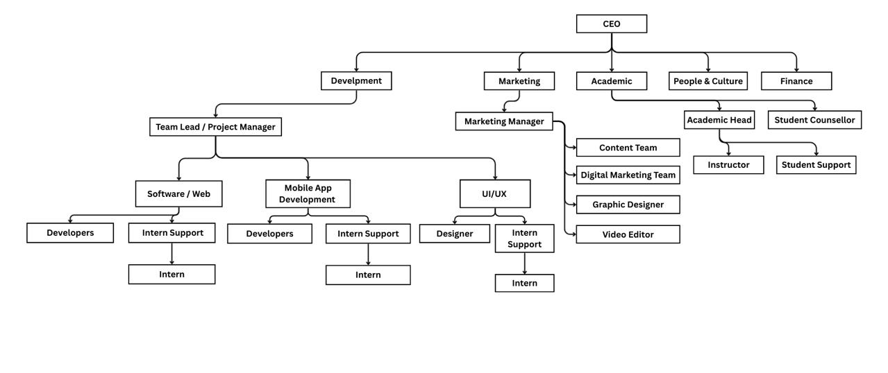
Figure 2.1: Organizational Hierarchy of Code IT
The engineering and technical team at Code IT is led by the CEO/Founder, Er. Sajal Shrestha, who oversees five primary departments: Development, Marketing, Academic, People & Culture, and Finance.
As a Mobile App Developer (Flutter) Intern, I am placed within the Development Department, which is managed by a Team Lead / Project Manager. This department is further divided into specialized execution units, including Mobile App/Web Developers, UI/UX Designers, Graphic Designers, and Video Editors. Each unit operates with dedicated intern support to ensure knowledge transfer and agile project delivery. Simultaneously, the Marketing Department is headed by a Marketing Manager overseeing Digital and Content teams, while the Academic Department is led by an Academic Head managing Instructors, Student Support, and Student Counsellors to ensure alignment between technical deliverables and educational outcomes.

2.3 Working Domains of the Organization
Code IT offers its services in various areas related to educational technology and software development. The primary service areas include:
- Custom Software Development: Building tailored web and mobile applications using modern stacks like Flutter, Laravel, and Python to solve specific business and educational challenges.
- Educational Technology Platforms: Developing comprehensive student portals, Learning Management Systems (LMS), and course-tracking modules that integrate live classes, recorded content, and certification systems.
- IT Training & Career Preparation: Providing job-focused courses in Full Stack Development, Cyber Security, QA, and Cloud Computing, backed by guaranteed internship opportunities and post-hiring support.
- Digital Marketing & Content Delivery: Managing academic content distribution and digital outreach to ensure students have seamless access to learning resources across multiple channels.

2.4 Description of Intern Department/Unit
I am placed in the Mobile App Development Department. The workflow follows an Agile/Scrum methodology where tasks are assigned via project management tools and tracked through regular sprint meetings. Code is managed via GitHub, and design handovers are executed using Figma.
Interns are paired with senior developers and the QA team to ensure code quality, proper API integration, and rigorous testing before deployment. During the internship period, my primary focus has been on translating the existing web-based student portal into a cross-platform mobile application. Tasks were assigned with clear deadlines, and progress was reviewed weekly by the Team Lead. Upon completing features, code was reviewed for complexity and efficiency, and after incorporating feedback, it was merged into the development branch for QA testing.

2.4.1 Duration
The internship duration as per university requirements and the offer letter is mentioned below:
Table 2.1: Internship Details
Parameter | Details
Internship Position | Mobile App Developer (Flutter) Intern
Time Period | April 12, 2026 – July 12, 2026
Total Duration | 91 days (77 working days)
Working Days | 6 Days (Sunday – Friday)
Office Hours | Flexible (Remote)
Supervisor | Er. Sajal Shrestha (CEO/Founder)
Organization | CODE IT

2.5 Literature Review
Mobile application development for educational platforms requires a careful balance of performance, accessibility, and secure data handling. Code IT’s student portal leverages modern cross-platform technologies to enhance user engagement by enabling efficient access to course materials, live streams, and administrative services. These technologies facilitate secure authentication, real-time data synchronization, and offline-capable media consumption, thereby streamlining the student experience and improving operational efficiency.
Globally, mobile-first learning platforms are critical for increasing student retention and accessibility. Flutter’s widget-based architecture and Dart’s asynchronous programming model are particularly beneficial for building responsive educational apps that handle diverse screen sizes and network conditions. However, these technologies also present challenges in state management, biometric security integration, and API reliability that must be addressed to ensure a production-grade user experience.
The design and implementation of the Code IT Student Portal mobile app involves several key technical considerations:
- Cross-Platform Development with Flutter: Flutter enables a single codebase to target both Android and iOS, reducing development time and ensuring feature parity. Its declarative UI framework allows for rapid iteration based on supervisor feedback, as demonstrated during the Week 4 UI rebuild and Week 10 flat design overhaul.
- State Management & API Integration: Efficient state management is critical for preventing redundant network calls and ensuring UI responsiveness. Proper integration of RESTful APIs for OTP verification, ticket submission, and course fetching ensures that students receive real-time updates without manual refreshes, directly impacting user satisfaction and platform reliability.
- Architectural Pattern (MVCS): The Code IT Student Portal mobile app follows the Model-View-Controller-Service (MVCS) architectural pattern to ensure separation of concerns and code maintainability. In this pattern, the Model handles data structures and API responses, the View comprises Flutter widgets for UI rendering, the Controller manages business logic and state transitions, and the Service layer abstracts REST API calls and local storage operations.
- Biometric Authentication & Local Security: Integrating native device security (fingerprint/Face ID) via packages like local_auth enhances convenience while maintaining security standards. This reduces login friction for students accessing sensitive academic records and payment receipts, aligning with modern mobile security best practices.
- Responsive UI & Accessibility: Educational apps must function flawlessly across diverse device form factors. Implementing dynamic layouts using MediaQuery and LayoutBuilder prevents overflow errors and ensures text readability on smaller screens, which is essential for students accessing content on budget devices or in low-bandwidth environments.
This literature forms the technical foundation for the tasks performed during the internship, directly informing decisions around architecture, security, and user experience design.

Chapter 3: Internship Activities

3.1 Roles and Responsibilities
As a Mobile App Developer (Flutter) Intern, my primary roles and responsibilities include:
- Translating Figma designs into responsive Flutter widgets.
- Integrating backend REST APIs and managing application state.
- Implementing local storage and secure authentication protocols.
- Collaborating with the QA team to identify, document, and resolve bugs.
- Optimizing UI layouts for various screen sizes and aspect ratios.

3.2 Weekly Log
The following table details the technical activities performed from the start of the internship up to the final evaluation (Week 1 to Week 13).
Table 3.1: Internship Weekly Log
Time Period | Activity
1st Week | Orientation and project overview. Joined official group chats and created GitHub repositories. Reviewed legacy web version of student portal for requirement mapping and researched initial mobile design layouts.
2nd Week | Research and design phase. Planned screen navigation flow and finalized folder structures. Designed UX pathways and prototyped Dashboard and Home screens in Figma. Conducted quality reviews on UI elements and submitted final Project Plan to supervisor for approval.
3rd Week | Custom UI implementation. Initialized Flutter project, set up global fonts/colors, and structured folders. Coded Support Page UI based on Figma designs, polished dynamic text form widgets, and integrated Support page into main navigation router. Received new design pivots from office.
4th Week | Official company UI rebuild. Modified global app themes to match official company Figma design files. Completely rebuilt Support and Suggestion layouts, refined assets using company logos, and ensured structural sync with top navigation menus. Submitted rebuilt screens for design approval.
5th Week | Backend and API integration. Programmed base HTTP networking rules and linked server data fields for Technical, General, and Counseling support APIs. Set up state management for live UI updates. Programmed OTP verification, password reset logic, and created custom “View My Tickets” list view.
6th Week | Structural refinement. Sketched custom route navigation maps and took over core app navigation structural work. Coded slide-out hamburger menu and top app header. Created static layouts for Terms of Service. Merged navigation components and conducted heavy loop-testing to prevent navigation crashes.
7th Week | UI responsiveness audit. Conducted responsiveness audits across various test monitors. Updated Support layouts for dynamic scaling. Fixed long form fields to prevent red overflow error flags on smaller phones. Adjusted side menu spacing for tall aspect ratios and confirmed uniform resizing.
8th Week | Certificates and course modules. Sketched media handler blueprints and developed “My Courses” layout grid. Verified server connection links and set up logic to email student completion certificates. Prepared and optimized iOS application icon packs (26 styles) for light/dark modes.
9th Week | Media integration and testing. Planned buffer targets for video players and created media viewer container. Programmed Live Classes panel layout and built Notes Section for text-based materials. Cleared home screen network loading issues and conducted real-device testing on physical iPhone.
10th Week | Biometric setup and UI overhaul. Researched device permissions for local fingerprint readers. Received supervisor feedback to transition from 3D buttons to modern “flat” aesthetic. Refactored UI styles across all files. Integrated biometric sensor packages (local_auth) to securely lock/unlock portal login view.
11th Week | QA collaboration and testing pipelines. Drafted local data rules for Course Purchase System. Helped QA team install Flutter tools and set up Postman for API testing. Held active app walkthrough sessions. Compiled and distributed APK builds for real-device Android testing.
12th Week | Recorded Courses & Transaction Modules. Formulated purchase listing flow and coded full buying layout for recorded courses. Built dynamic search bar with debouncing. Programmed attachment button for bank receipt uploads with image compression. Reused receipt-upload component across enrollment screens. Cleaned up repetitive layout code.
13th Week | Bug Resolution & Final Submission. Grouped QA-reported bugs into checklist. Added connectivity_plus package for offline alerts. Fixed text rendering errors, sorting filter crashes, duplicate download issues, and authentication loop errors. Ran full regression tests and submitted completed bug-free app to manager. Completed final handover documentation and source code submission on July 12.

3.3 Description of the Project Involved During Internship
The Code IT Student Portal Mobile App is a cross-platform application designed to give students full access to their educational dashboard. Key features include a personalized dashboard, course purchasing and viewing, live class streaming, certificate generation, support ticketing, and secure biometric login. The project focuses on creating a seamless integration of extracted data into existing business systems, providing accurate and efficient information management that supports improved decision-making and operational efficiency for the students.

3.4 Tasks/Activities Performed (Technical Details)
During the complete 13-week internship, the following technical tasks were executed:

3.4.1 UI/UX Prototyping and Implementation
Analyzed the legacy web version to map out mobile-specific user pathways. Designed and prototyped screens in Figma. Rebuilt the UI using official company design systems, transitioning from 3D/shadowed buttons to a modern, clean, "flat" aesthetic. Ensured UI responsiveness across varying aspect ratios, fixing text cut-offs and dynamic form field scaling using Flutter's LayoutBuilder and MediaQuery.
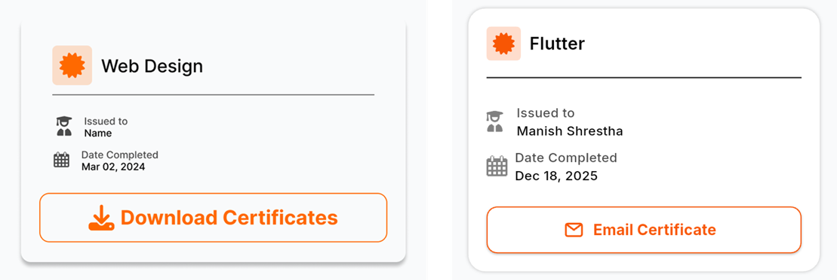
Figure 3.1: Figma UI/UX Prototype vs Implemented Flutter Screen

3.4.2 API Integration and State Management
Programmed base networking rules using HTTP clients within a dedicated Service layer, following the MVCS pattern to isolate API logic from UI components. Integrated RESTful APIs for Technical, General, and Counseling support tickets through service classes, while Controllers managed state updates and Views reactively displayed server data (e.g., OTP verification, password resets). This separation prevented redundant network calls and enabled rapid UI iteration during the flat design overhaul without disrupting backend integration.
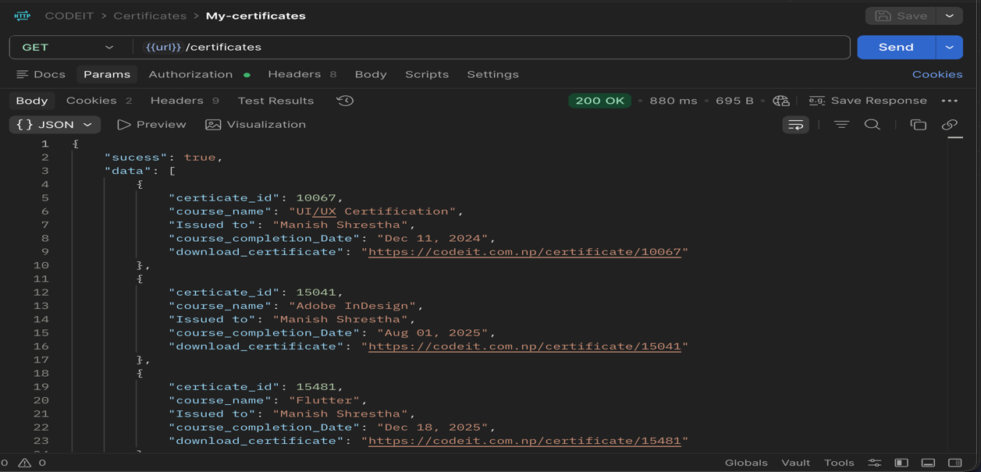
Figure 3.2: RESTful API Testing via Postman

3.4.3 Media and Course Modules
Developed the "My Courses" layout grid and verified server connection links. Integrated a custom video player with buffer targets and stop/start logic for pre-recorded and live classes. Built a notes section for students to save and retrieve text-based class materials.
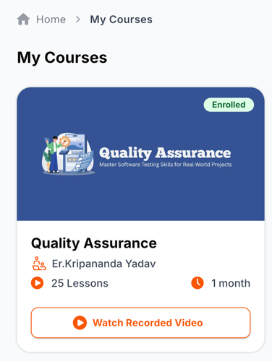
Figure 3.3: My Courses Screen

3.4.4 Security and Biometric Integration
Researched and implemented local device permission requirements for biometric sensors. Successfully linked the phone’s native fingerprint/Face ID tool packages (local_auth) to securely lock and unlock the portal login view, enhancing user convenience and security.
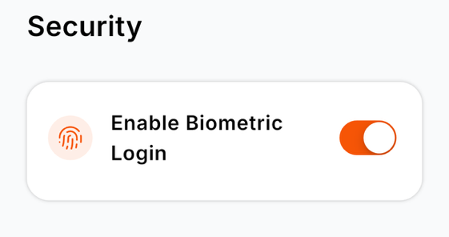
Figure 3.4: Biometric Authentication Toggle

3.4.5 QA Collaboration and Testing Pipelines
Assisted the Quality Assurance (QA) team in setting up Flutter environments and Postman for backend API testing. Conducted active walkthroughs of the app's architecture for the QA team. Compiled and distributed APK builds for real-device Android testing to identify edge-case bugs before the final transaction modules are built.

3.4.6 Course Enrollment & Manual Payment Verification
Developed a unified Course Enrollment Module used for both new course registrations and recorded course purchases. The interface displays a static QR code for eSewa, Khalti, mobile banking, or direct bank transfers. Students manually enter the course price in their payment app, complete the transaction, capture a screenshot of the success confirmation, and upload it directly within the app using image_picker with file compression. Uploaded proofs are stored securely and flagged as "Pending Verification" in the admin dashboard. Upon manual review and approval by the administrator, the backend automatically grants access to the enrolled or purchased course. Implemented debounced search filtering for instant course discovery and applied DRY principles to reuse the same receipt-upload component across all enrollment screens, ensuring UI consistency and reducing code duplication.

3.4.7 Bug Resolution & Production Deployment
Resolved 12+ edge-case bugs identified during QA testing including authentication loop errors, sorting filter crashes, duplicate file downloads, and text rendering issues. Integrated connectivity_plus ^7.1.1 and internet_connection_checker_plus ^3.0.1 for global offline detection and graceful degradation. Conducted full regression testing to ensure fixes did not break existing features. Submitted completed bug-free application and all source code/assets to supervisor on July 12, 2026, completing the full internship deliverable.

Chapter 4: Conclusion and Learning Outcomes

4.1 Conclusion
The three-month internship at Code IT has been incredibly rewarding and transformative. As of the final submission on July 12, 2026, the project is 100% complete. The core architecture, UI/UX implementation, API networking, media handling, biometric security layers, unified course enrollment with manual payment verification, and global offline detection have been successfully developed, tested, and handed over. Working alongside experienced professionals and receiving direct feedback on UI aesthetics greatly contributed to my professional growth. The final production build was submitted bug-free after comprehensive regression testing, fulfilling all technical and professional objectives outlined at the start of the internship.

4.2 Learning Outcome
During the internship at Code IT, the opportunity arose to immerse in various technologies and processes integral to the company's operations in the mobile application development sector. Here are the key learning outcomes from the experience:

- Flutter & Dart Proficiency: Gained hands-on mastery in building responsive, cross-platform UIs and managing asynchronous data streams using Dart.
- API & State Management: Learned how to efficiently connect frontend mobile interfaces with backend REST APIs and manage application state to prevent redundant network calls and UI lag.
- Device Hardware Integration: Integrated local_auth ^3.0.1 with Darwin-specific overrides, image_picker ^1.2.2 for receipt uploads, and connectivity_plus ^7.1.1 for offline detection — covering three distinct native device capabilities
- Software Architecture: Applied the MVCS pattern to enforce separation of concerns across Model, View, Controller, and Service layers, enabling scalable code organization and efficient UI/backend decoupling.
- Cross-Platform Responsiveness & Accessibility: Mastered Flutter’s LayoutBuilder and MediaQuery to build adaptive UIs that function flawlessly across diverse screen sizes and aspect ratios, fixing overflow errors and ensuring text readability on budget devices — a critical skill for educational apps targeting students with varying hardware capabilities.
- Course Enrollment & Transaction Implementation: Built a unified enrollment flow where students scan a static QR, manually enter the price, upload payment screenshots, and receive course access after admin approval - gaining practical experience in fintech UX design, file upload handling, reusable UI components, and role-based access control for digital content delivery.
- Regression Testing & Bug Resolution: Systematically categorized QA-reported bugs, fixed critical issues (auth loops, sort crashes, duplicate downloads), and ran full regression tests to ensure zero regressions before production submission.
- Production Deployment & Professional Handover: Completed final project closure including documentation, source code handover, and asset transfer - learning professional project completion protocols beyond coding.
- Technical Documentation & Knowledge Transfer: Developed the ability to document technical decisions clearly (e.g., MVCS architecture rationale, API integration patterns) and conduct effective app walkthrough sessions for non-developer stakeholders (QA team), bridging the communication gap between development and quality assurance to accelerate bug identification and resolution.
Overall, this internship has provided a solid foundation for my future career aspirations as a Mobile App Developer and instilled the confidence to operate efficiently in a professional, collaborative environment.

References
Code IT. (n.d.). Official website. https://codeit.com.np/
Dart Team. (n.d.). Language tour and asynchronous programming. https://dart.dev/guides
Dio Contributors. (n.d.). dio [Computer software]. pub.dev. https://pub.dev/packages/dio
Figma. (n.d.). Best practices for mobile UI/UX prototyping. https://help.figma.com/
Flutter. (n.d.). Flutter architectural overview. Flutter Documentation. https://docs.flutter.dev/resources/architectural-overview
Flutter. (n.d.). image_picker (Version 1.2.2) [Computer software]. pub.dev. https://pub.dev/packages/image_picker
Flutter. (n.d.). local_auth (Version 3.0.2) [Computer software]. pub.dev. https://pub.dev/packages/local_auth
Flutter Community. (n.d.). connectivity_plus (Version 7.1.1) [Computer software]. pub.dev. https://pub.dev/packages/connectivity_plus
GetX Team. (n.d.). GetX [Computer software]. pub.dev. https://pub.dev/packages/get
Postman. (n.d.). Postman API platform. https://www.postman.com/

Appendices
Appendix A: Login Screen
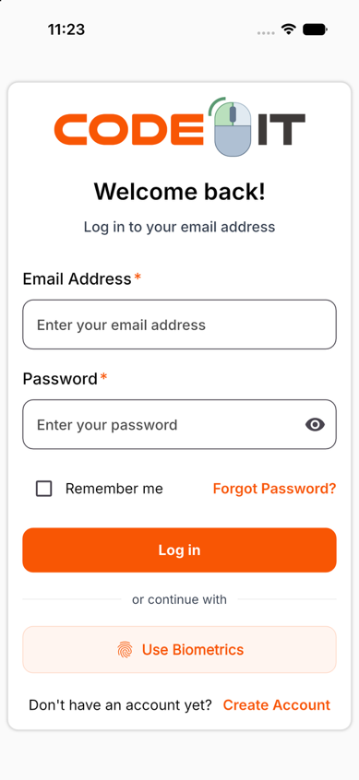
Figure A.1: Login screen
Appendix B: Dashboard Screen
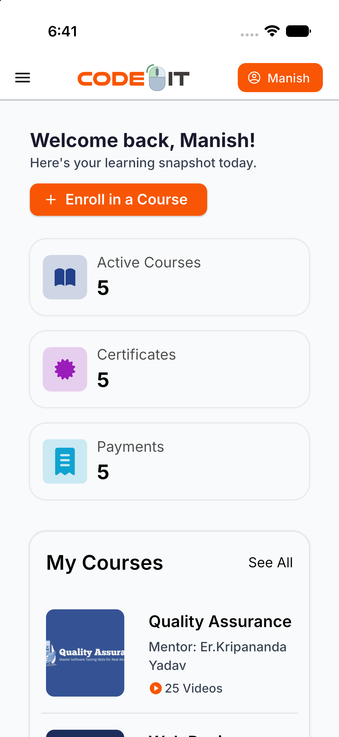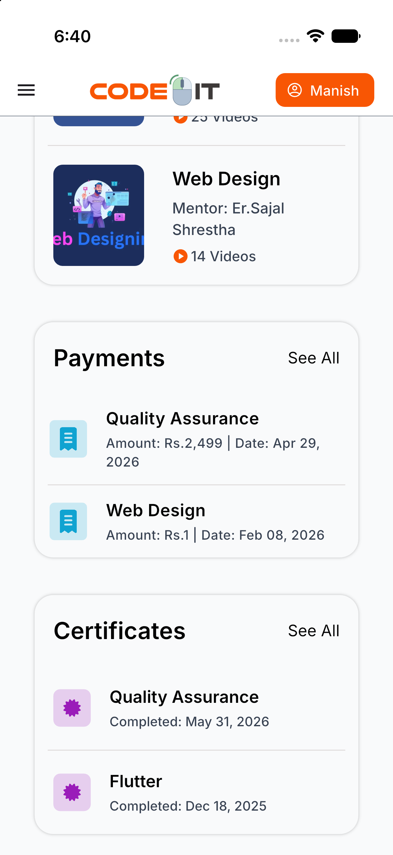
Figure B.1: Dashboard screen
Appendix C: Upcoming Classes Screen
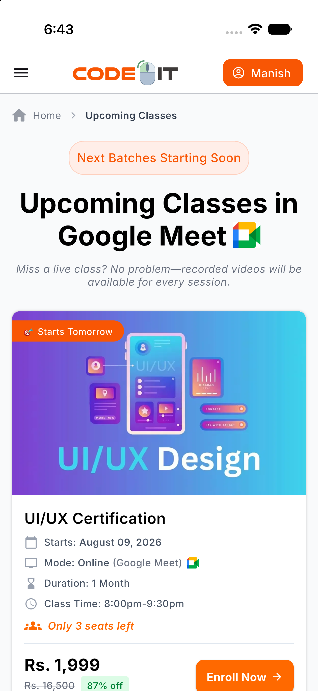
Figure C.1: Upcoming Classes screen
Appendix D: My Courses Screen
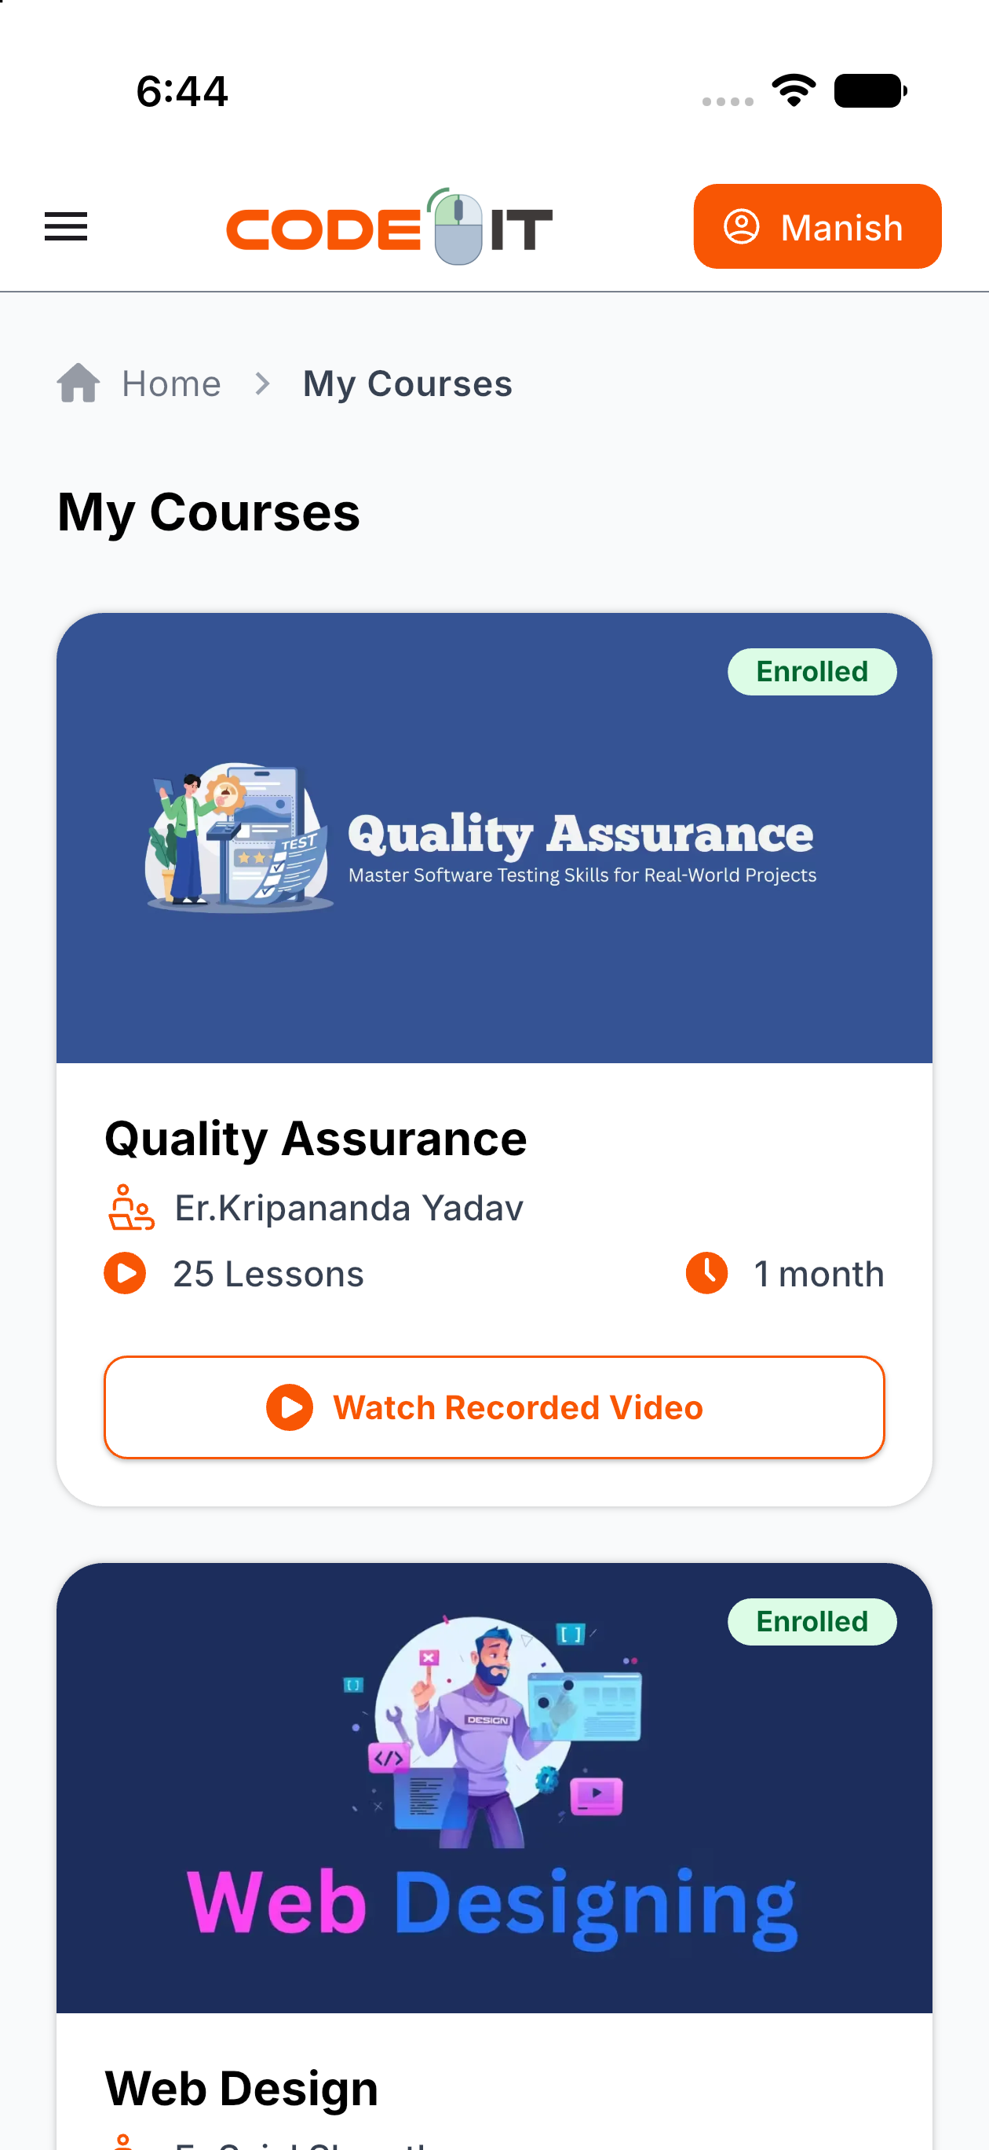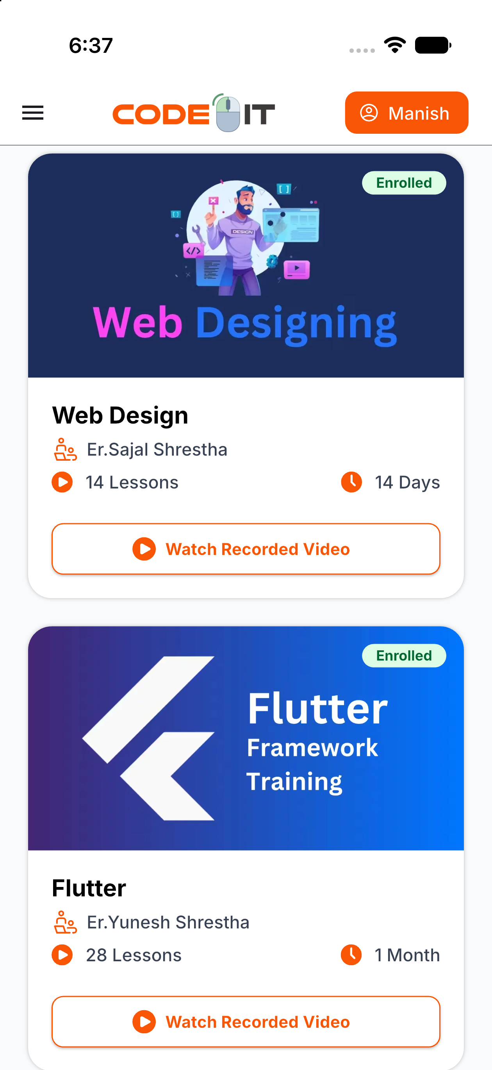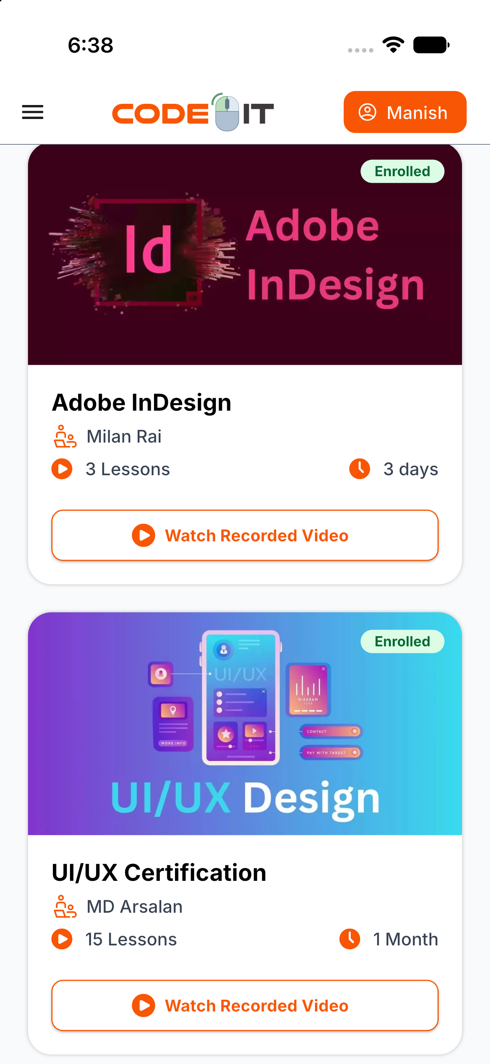
Figure D.1: My Courses screen

Appendix E: Certificates Screen
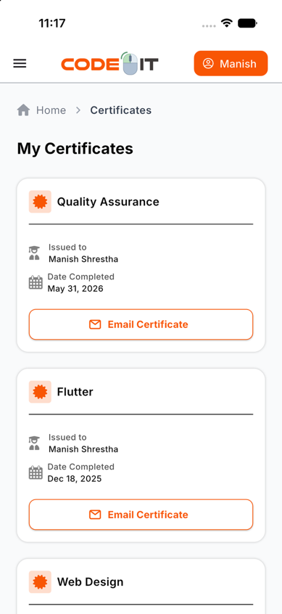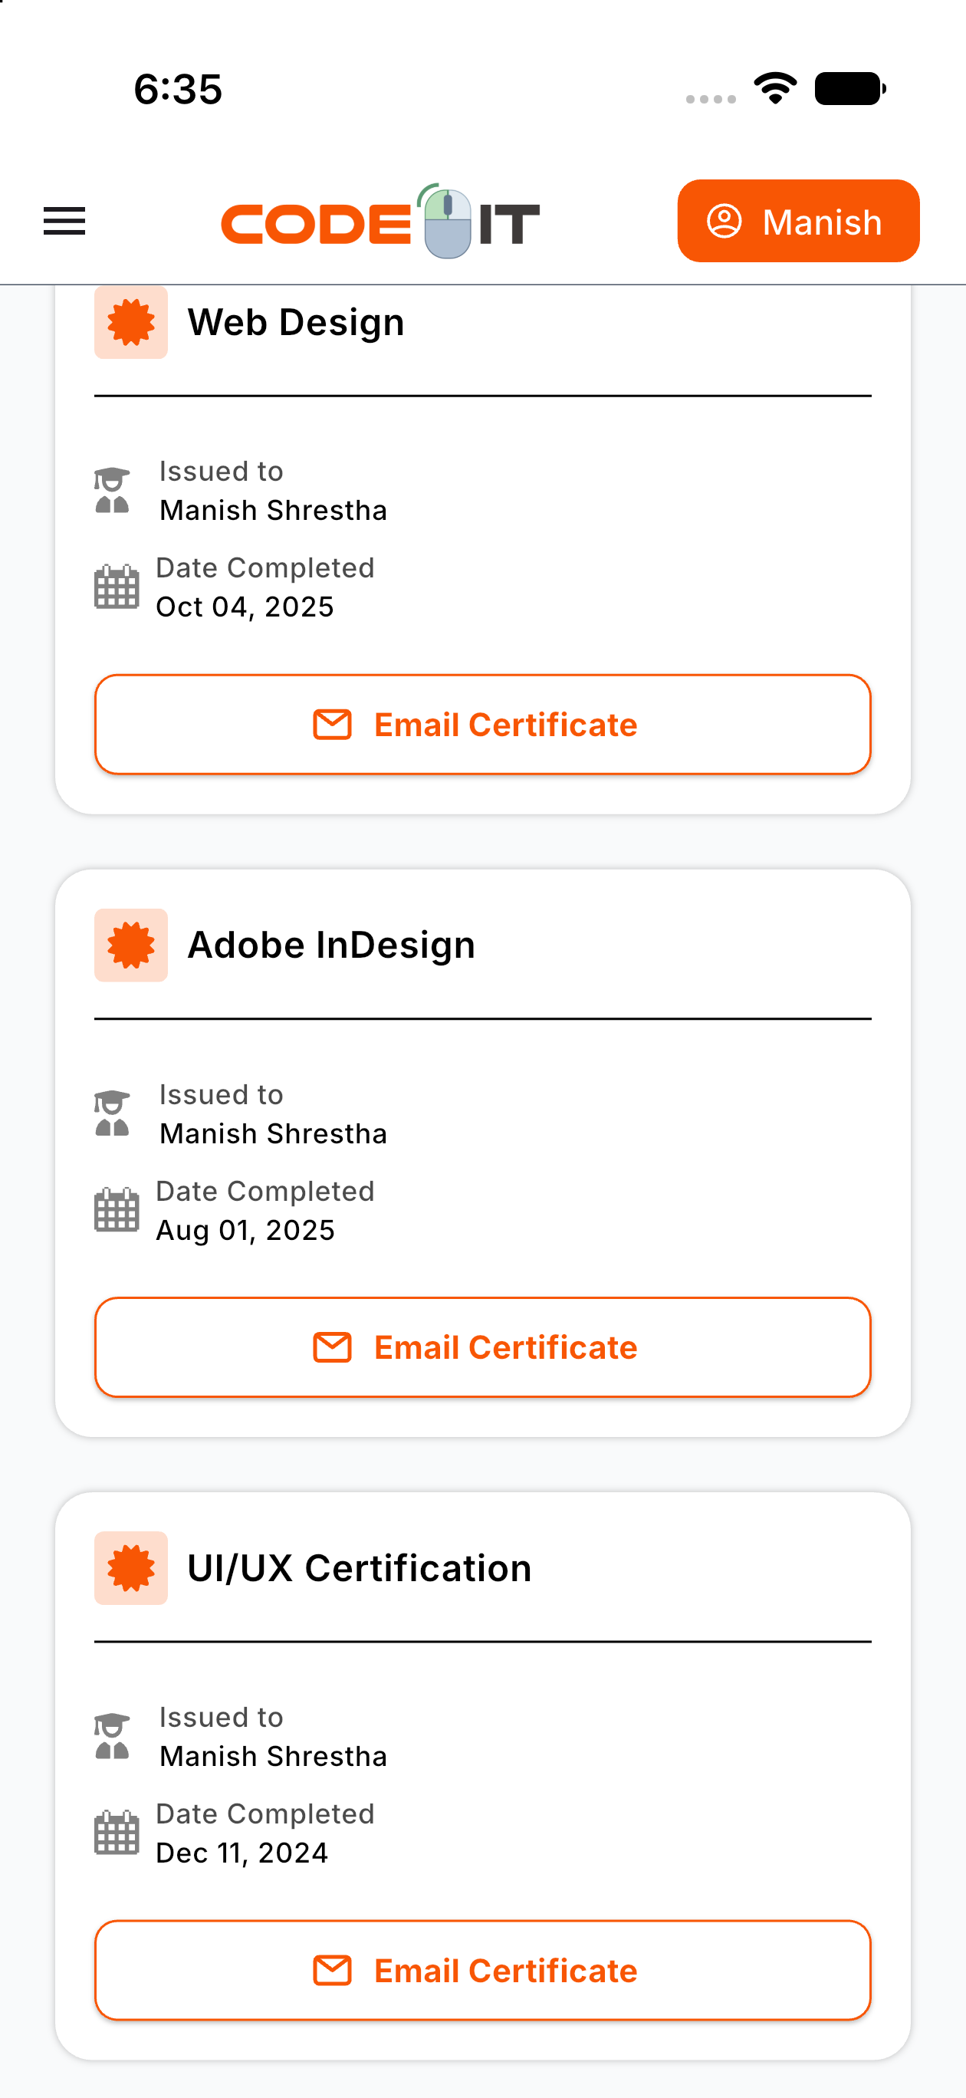
Figure E.1: Certificates screen
Appendix F: Support Screen
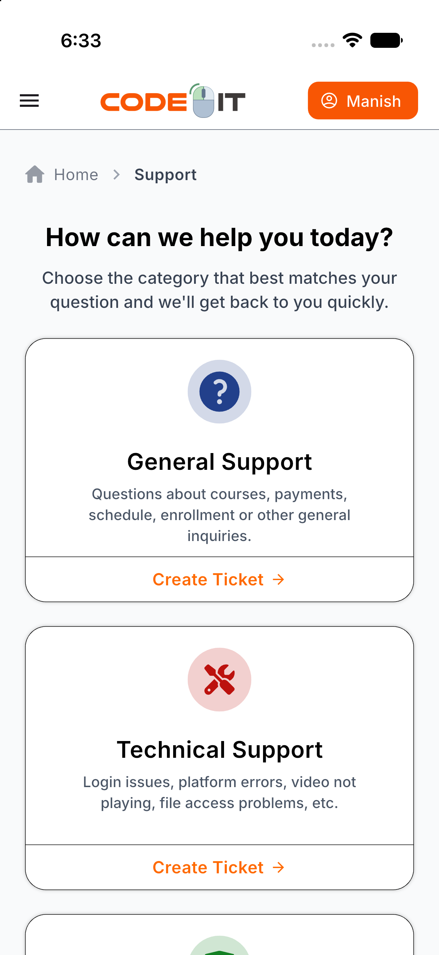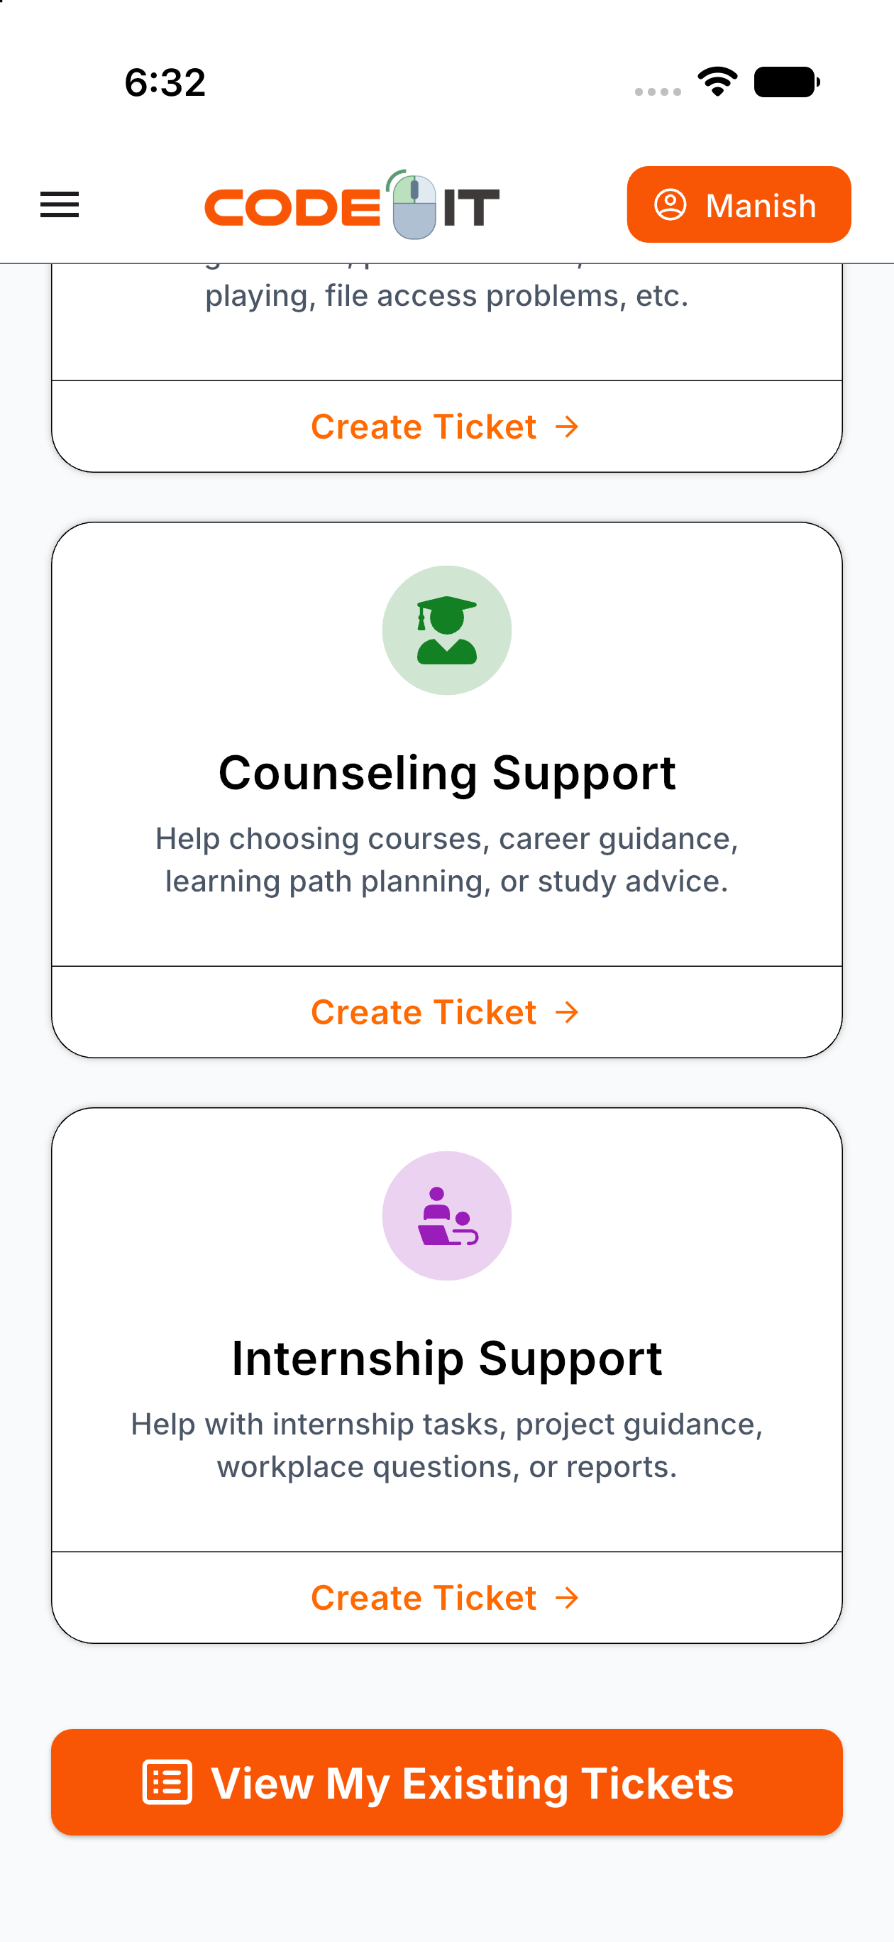
Figure F.1: Support screen
Appendix G: Suggestions Screen
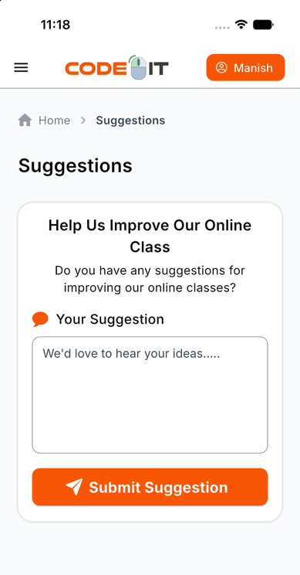
Figure G.1: Suggestions screen

Appendix H: Video Playing Screen
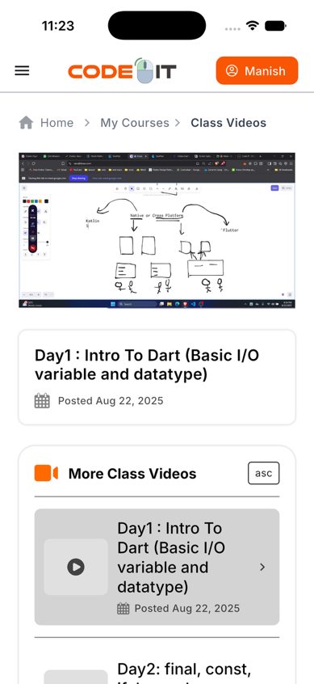
Figure H.1: Class video player screen

Appendix I: Course Enrollment Screen
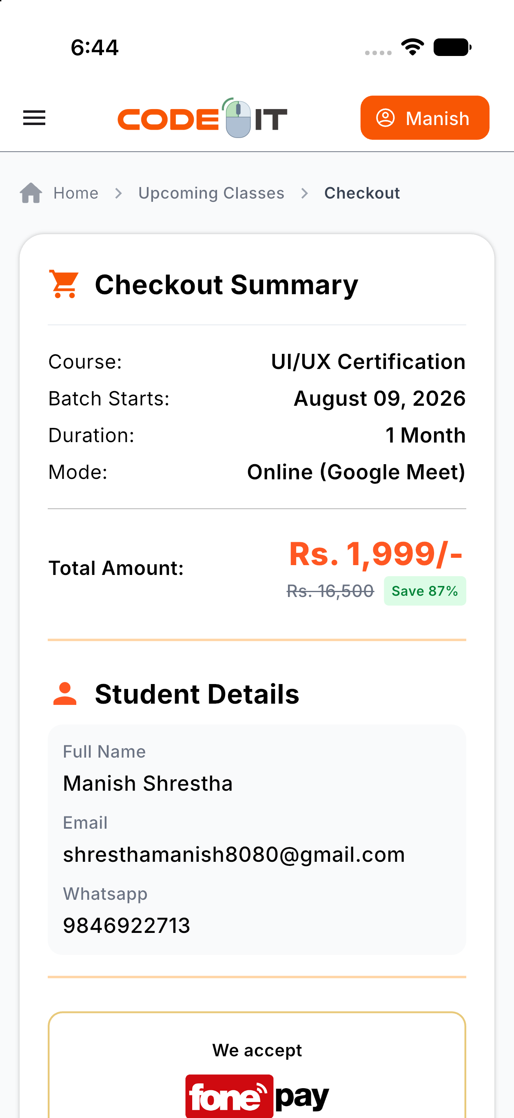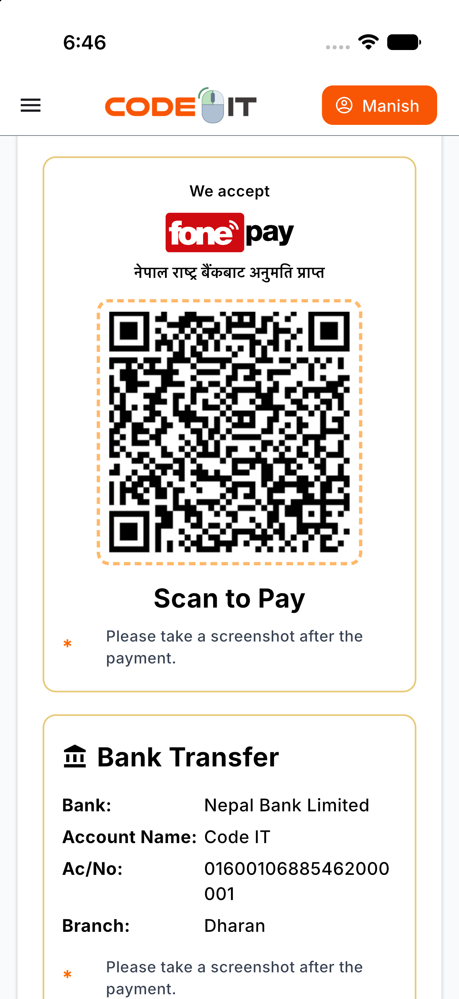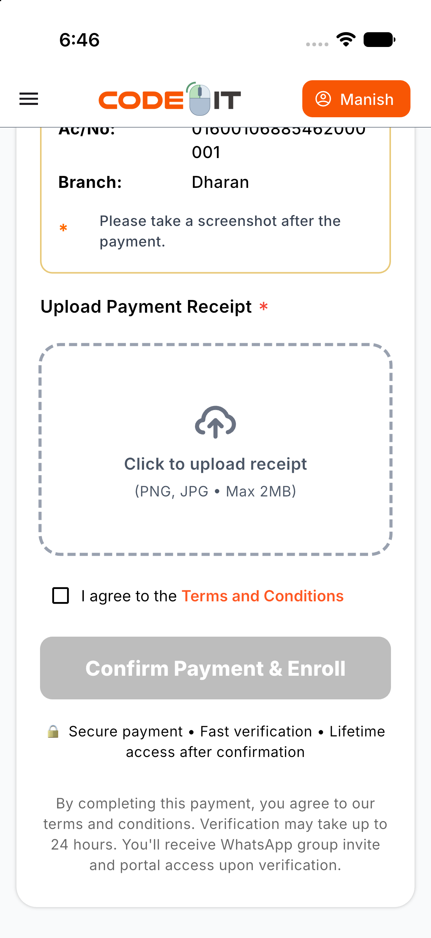
Figure I.1: Course enrollment screen with static QR code screen

Appendix J: Recorded Videos Purchase Screen
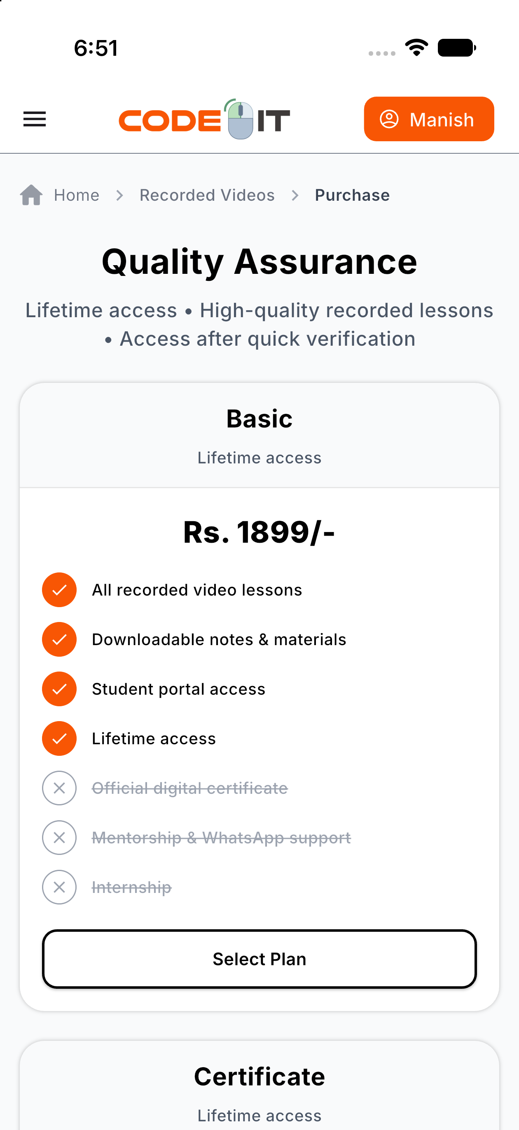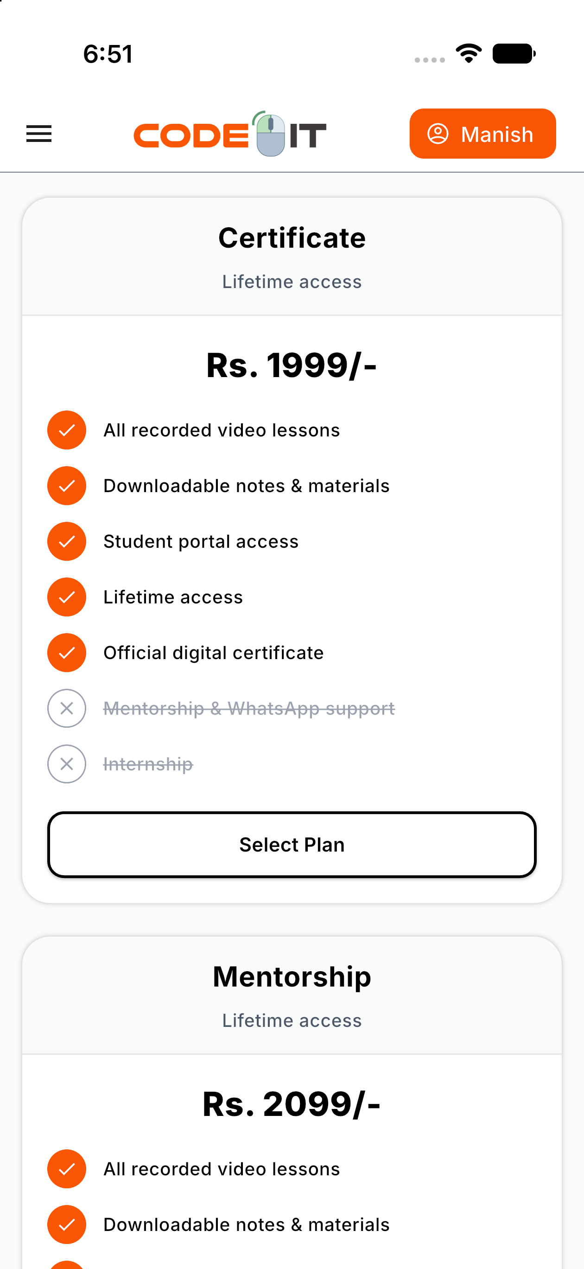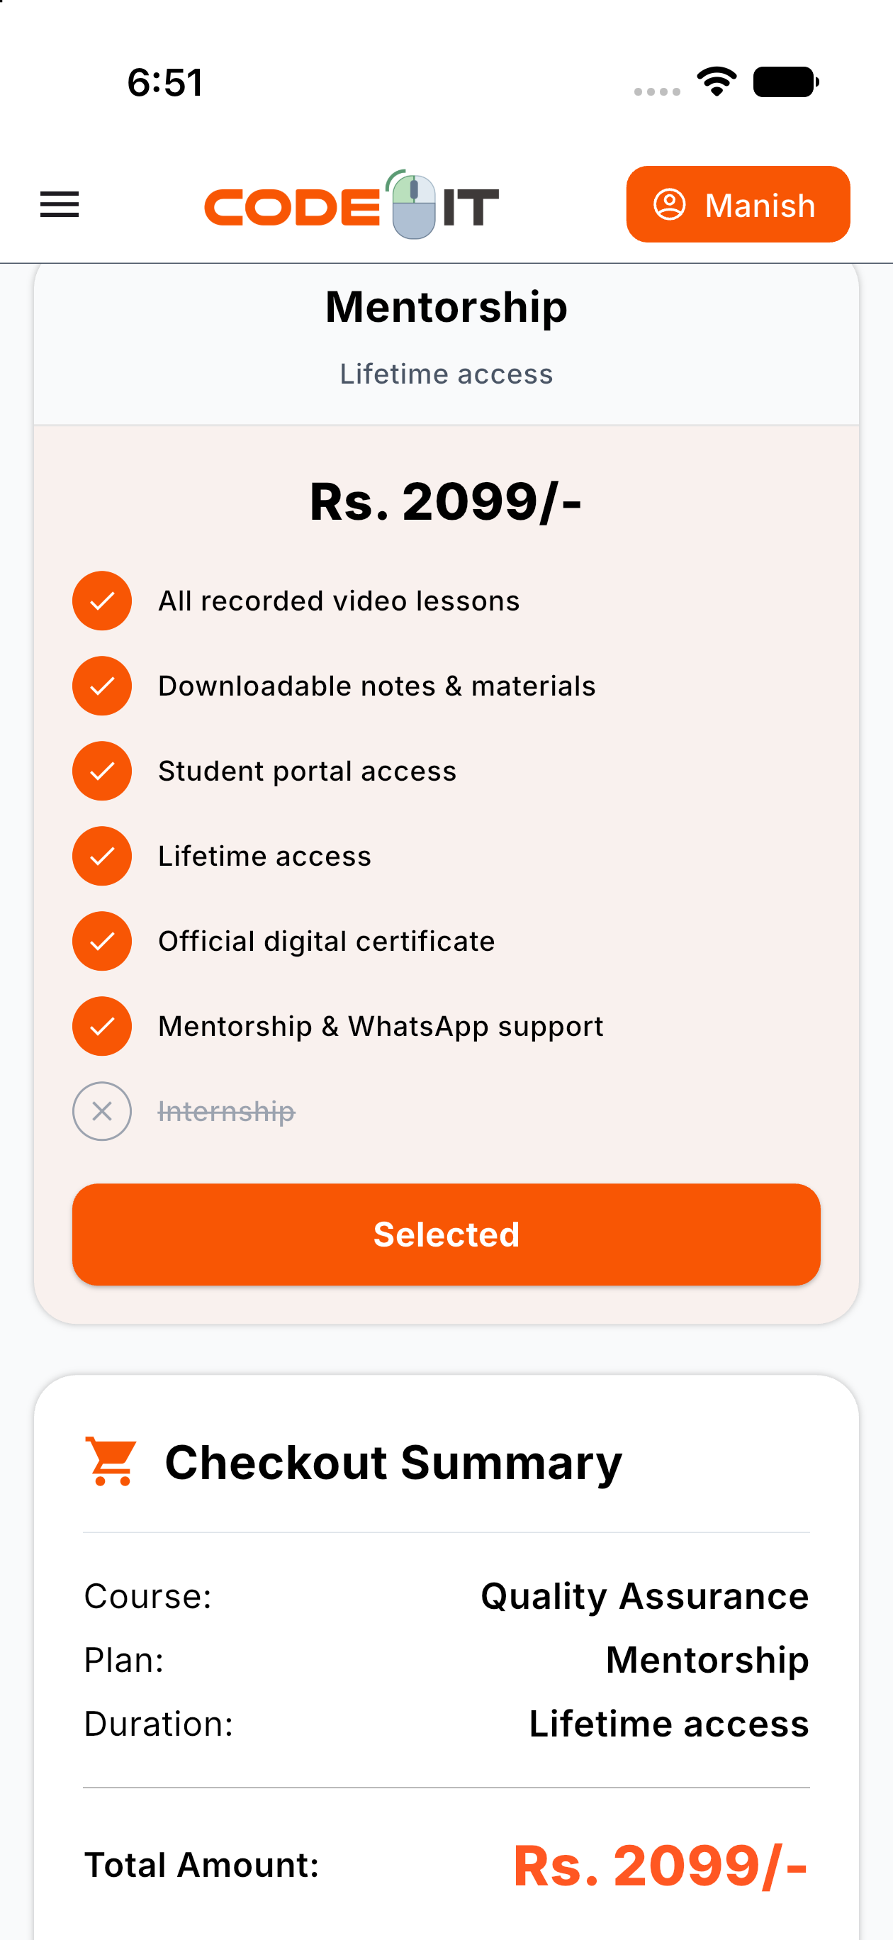
Figure J.1: Recorded Videos Purchase screen
Appendix K: Daily Work Log
